INDEX

1. Research 1

2. Feasibility Studies 2

2.1 Technical Feasibility: 2

2.2 Economic Feasibility 2

2.3 Operational Feasibility: 2

Software Development Life Cycle 3

3. System Requirement specification 4

3.1 Introduction to SRS 4

3.2 Abstract 4

3.3 System Users 5

3.4 Modules 5

3.5 Modules Description 5

3.6 HARDWARE REQIUREMNTS 6

1. [Technology Description](#_Technology description) 7

4..1 Limitations and Features: 8

1. Data Flow Diagram 9

5.1 Context Level DFD: 9

5.2 1st Level DFD 10

5.3 2nd Level DFD 11

6. [E-R Diagram](#_E-R Diagram for Banking Management System) 14

7. [Activity Diagram](#_Activity Diagram) 15

8. [USECASE Diagram](#_USE CASE Diagram) 16

9. [Data Dictionary](#_Data Dictionary) 17

10.[Form Design(Screenshot)](#_Form Design (Screenshots)) 19

10.1 Main Page 19

10.2 Login Page 20

10.3 Admin Home Account 21

10.4 Customer Home Account 22

10.5 Employee Home Account 23

11.[Future Enhancement](#_Future Enhancement) 24

12.[BIBLIOGRAPHY](#_12 .BIBLIOGRAPHY) 25

#### Research

# Research may be very broadly defined as systematic gathering of data and information and its analysis for advancement of knowledge in any subject. research attempts to find answer intellectual and practical questions through application of systematic methods.

Types of research can be classified in many different ways. some major ways of classifying research include the following.

* Descriptive Research
* Applied Research
* Quantitative Research
* Conceptual Research

Descriptive research concentrates on finding facts to ascertain the nature of something as it exists. In contrast analytical research is concerned with determining validity of hypothesis based on analysis of facts collected.

Applied research is carried out to find answers to practical problems to be solved and as an aid in decision making in different areas including product design, process design and policy making. Fundamental research is carried out as more to satisfy intellectual curiosity, than with the intention of using the research findings for any immediate practical application.

Quantitative research studies such aspects of the research subject which are not quantifiable, and hence not subject to measurement and quantitative analysis. In contrast quantitative research makes substantial use of measurements and quantitative analysis techniques.

Conceptual research is involving investigation of thoughts and ideas and developing new ideas or interpreting the old ones based on logical reasoning. In contrast empirical research is based on firm verifiable data collected by either observation of facts under natural condition or obtained through experimentation.

**It’s Benefit**

* Better understand evolving community needs
* Inform program development and refinement.
* We can find which type of new things need.
* Measure the outcomes of programs and account for use of resources.
* Create new understanding about what works and what does not.

#### Feasibility Studies

Feasibility studies aim to objectively and rationally uncover the strengths and Weaknesses of the existing system or proposed venture. In its simplest term, the two criteria to judge feasibility are cost required and value to be attained. As such, a well-designed feasibility study should provide historical background of the project. Generally, feasibility studies precede technical development and Project implementation.

## 

## **2.1 Technical Feasibility:**

Generally, feasibility studies precede technical development and project implementation. The assessment is based on a system requirement in terms of Input, Processes, Output, Fields, Programs, and Procedure. This can be quantified in terms of volumes of data, trends, frequency of updating, etc., in order to estimate whether the new system will perform adequately or not. Technological feasibility is carried out to determine the capability, in terms of software, hardware, personnel and expertise, to handle the completion of the project. When writing a feasibility report the following should be taken to consideration:

* A brief description of the business
* The part of the business being examined
* The human and economic factor
* The possible solutions to the problems

In technical Feasibility we can show which type of Technology we are using to build our system like OS- windows and SQL server management studio .

## 

## **2.2 Economic Feasibility**

Economic analysis is the most frequently used method for evaluating the effectiveness of a new system. More commonly known as cost/benefit analysis, the procedure is to determine the benefits and savings that are expected from a candidate system and compare them with costs. we can access our system on any operating system through using browser. The only cost of our system is server cost.

## **2.3 Operational Feasibility:**

Operational feasibility is a measure of how well a proposed system solves the problems, and takes advantage of the opportunities identified during scope definition and how it satisfies the requirements identified in the requirements analysis phase of system development the operational feasibility of the system can be checked as it solves the problems and reduces the complications occurring in the paper-pencil test. We have also reduced the paper work here if we find any error then we provide a facility of complain box where we can send their error through admin and other user then can easily solve their error.

**Software Development Life Cycle**

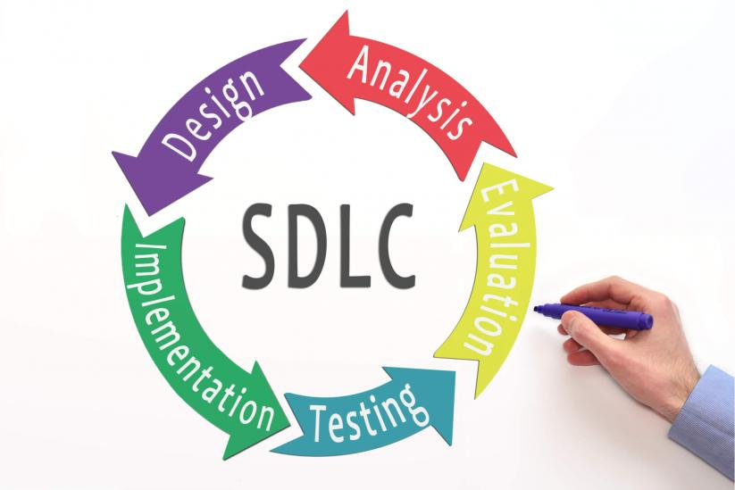

* **System Analysis**

At this step the developers decide a road map of their plan and try to bring up the best software model suitable for the project. System analysis includes Understanding of software product limitations, learning system related problems or changes to be done in existing systems beforehand, identifying and addressing the impact of project on organization and personnel etc. The project team analyses the scope of the project and plans the schedule and resources accordingly.

* **Software Design**

Next step is to bring down whole knowledge of requirements and analysis on the desk and design the software product. The inputs from users and information gathered in requirement gathering phase are the inputs of this step. The output of this step comes in the form of two designs; logical design and physical design. Engineers produce meta-data and data dictionaries, logical diagrams, data-flow diagrams and in some cases pseudo codes.

* **Implementation**

This means installing the software on user machines. At times, software needs post-installation configurations at user end. Software is tested for portability and adaptability and integration related issues are solved during implementation.

* **Evolution**

In evolution phase we can check how to increases or growth of our system in environment. Then also they can check it is user-friendly or not.

* **Testing**

An estimate says that 50% of whole software development process should be tested. Errors may ruin the software from critical level to its own removal. Software testing is done while coding by the developers and thorough testing is conducted by testing experts at various levels of code such as module testing, program testing, product testing, in-house testing and testing the product at user’s end. Early discovery of errors and their remedy is the key to reliable software.

#### System Requirement specification

**3.1 Introduction to SRS**

A software requirements specification (SRS) is a description of a software system to be developed. It lays out functional and non-functional requirements, and may include a set of use cases that describe user interactions that the software must provide.

**3.2** **Abstract**

The Banking Management System is an application for maintaining a person's account in a bank. In this project I tried to show the working of a banking account system and cover the basic functionality of a Banking Management System. The main aim of this project is to develop software for Banking Management System.This project has been developed to carry out the processes easily and quickly.

## **3.3 System Users**

1. Administrator

2. Employee

3. Customer

**1.Administrator**: - The role of bank admin is to create id and password for customer control and employee control for website. Admin can also view all transaction and all information of customer.

**2**.**Employee**: - The role of Employee control is to view reports of customer account and also done transaction according to need of customer and also generate OTP (one time password) for transaction.

**3**.**Customer**: - The role of Customer control is to create new customer account according to application form and also update account if needed and view reports of customer account and also can change password, view transaction report.

## **3.4 Modules**

* List of Modules
* Create New Account
* Login
* Bank Accounts
* Fund Transfer
* Transactions
* Users

**3.5 Modules Description**

1. **Create New Account**

A customer who want account in bank through this module they can open their account. This module receives the customer profile details and the bank account details with the proof of the ownership of the bank account.

1. **Login**

Virtual account holders can login in to the system using this module. Thus this is the secured login page for the customers in the website.

1. **Bank Accounts**

A customer may have more than one bank account in various banks, In this case, the customer prompted to decide which bank account should reflect in the Account debit or amount credit. For these operations customers can add their owned Bank accounts here and it will be approved by the administrations of the system.

1. **Fund Transfer**

This is the module to make fund transfer to the virtual bank account Holders or the usual bank account holders from the customer's specified bank account.

1. **Transactions**

This module displays the history of transaction done by customer and show in particular data format with transaction information.

1. **Users**

This module displays the different kind of users who handle the whole system with their respective login id and password.

**3.6 HARDWARE REQIUREMNTS**

* The hardware used for the development of the project is:

PROCESSOR : PENTIUM III 866 MHz

RAM : 1 GB or More

MONITOR : 15” COLOR

HARD DISK : 20 GB

CD DRIVE : LG 52X

KEYBOARD : STANDARD 102 KEYS

MOUSE : 3 BUTTONS

**Software Requirements**

Internet Browser such as Internet Explorer 6.0 and higher or another browser of the same generation is required to access the application.

* The software used for the development of the project is:

OPERATING SYSTEM : Windows XP Professional

ENVIRONMENT : Visual Studio .NET 2003

.NET FRAMEWORK : Version 1.1

LANGUAGE : C#.NET, ASP.NET

BACKEND : SQL SERVER 2000

#### Technology description

* ASP.NET:
* ASP.NETis an open-source server-side web application framework designed for web development to produce dynamic web pages.
* ASP.NET is built on the Common Language Run-time (CLR), allowing programmers to write ASP.NET code using any supported .NET language.
* MySQL:
* My SQL is the world wide most popular Open Source Relational SQL Database Management System.
* MySQL is one of the best RDBMS being used for developing various web-based software applications. MySQL is developed, marketed and supported by MySQL AB, which is a Swedish company.
* CSS:
* CSS stands for Cascading Style Sheets
* CSS describes how HTML elements are to be displayed on screen, paper, or in other media
* CSS saves a lot of work. It can control the layout of multiple web pages all at once.
* **C#**:
* C# is a modern, general purpose, object-oriented programming language designed around the Common Language Infrastructure.
* C# is used as a back-end programming language in ASP.NET.

**4.1 Limitation and Features**

Limitations:

* Lack of security of data.
* Time consuming.
* Consumes large volume of paper work.
* Needs manual calculations.

Features:

* Our website is totally platform dependent that means it can be used with desktop only.
* The proposed system automates the existing system. It decreases paper work and makes record maintenance easy by having a database for account information and transaction history.
* We are providing transaction option for customer to make their work easy.

#### DFD

**5.1 Context Level DFD Banking Management Systems**

Login and Manage A/c Account summary/Report

Banking Management System

Admin

Customer

Employee

Edit and Takes Reports Login & Account Details

Transaction Reports Login and Create Transaction

Description: Above Diagram is Context Level diagram for banking management system.In this diagram Admin, Customer and Employee send request for login and get response according their requirement.

**5.2 1st Level DFD Customer Banking Management System**

Employee

Customer

1.0

Create Account

2.0

Maintain Account

Account

3.0

Transaction

4.0

Genrate   
OTP

5.0

view Reports

Admin

Description:Above Diagram is 1st Level diagram for banking management system.This diagram descrivbes the basic flow of banking management system.

**5.3 2nd Level DFD Admin Banking Management System**

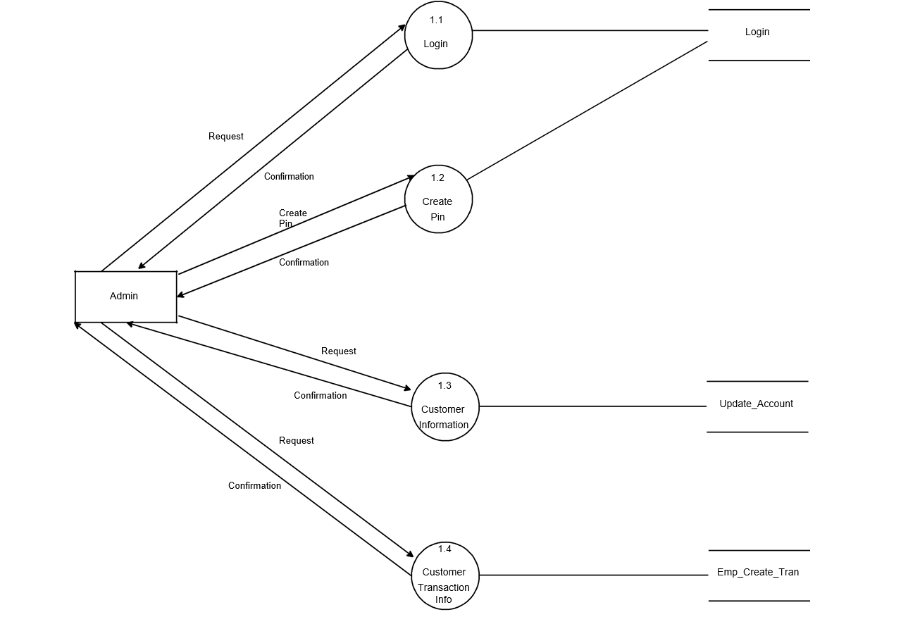

**5.3(1) 2nd Level DFD Customer Banking Management System**

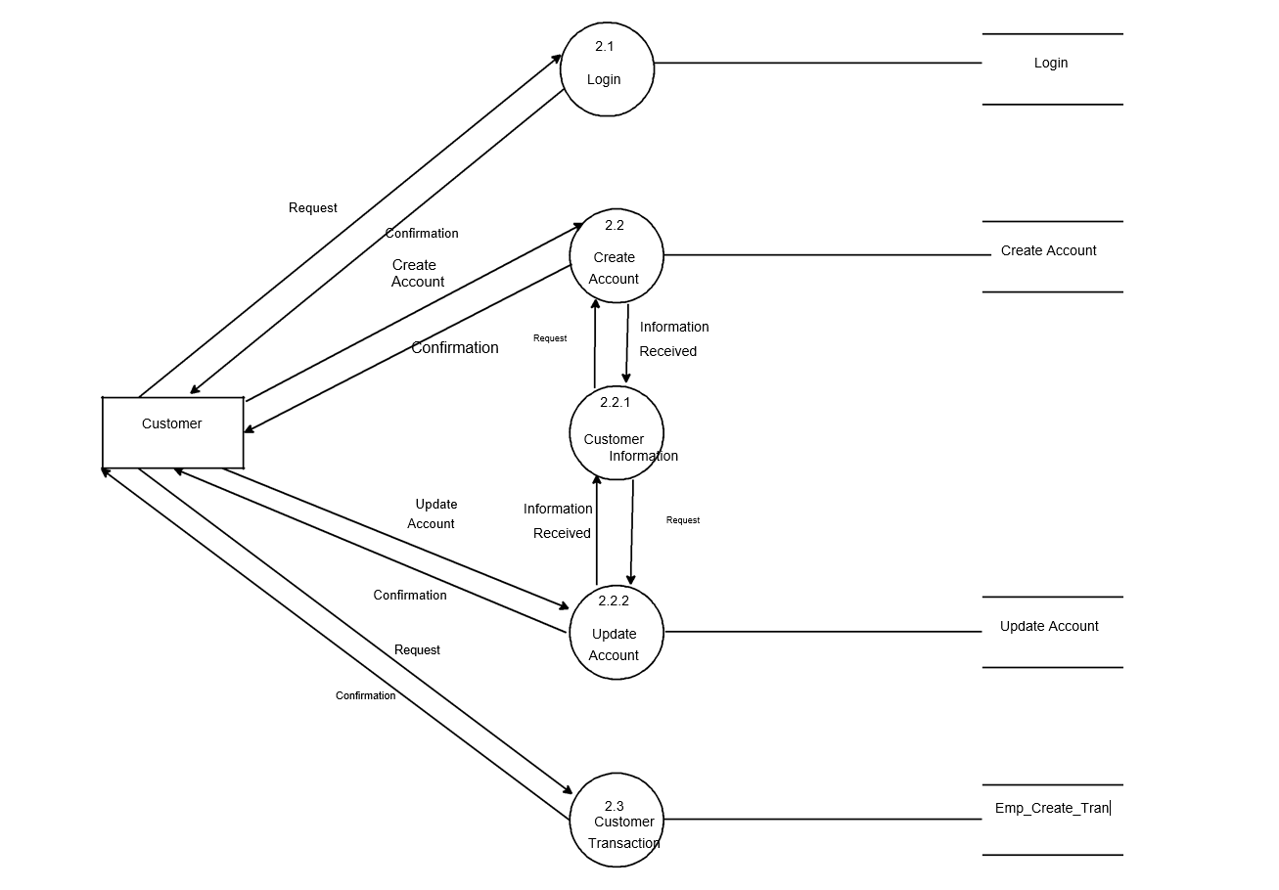

5**.3(2) 2nd Level DFD Admin Banking Management System**

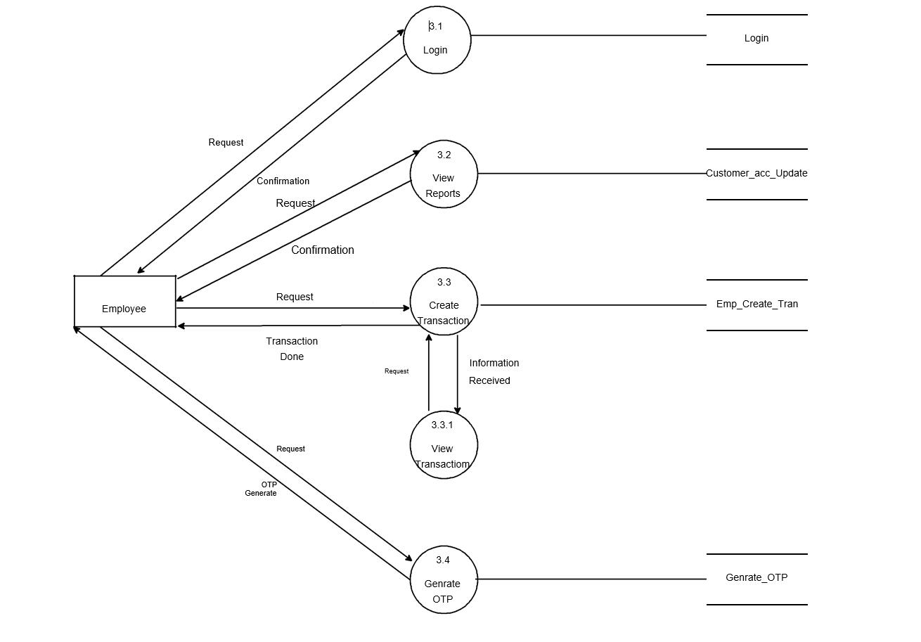

# E-R Diagram for Banking Management System

**Admin Info**

Admin

**Branch**

Contact No.

Branch Name

Branch-ID

Loan

Branch

**Loan**

**Customer**

Borrow

Loan-No.

Amount

Customer Name

Customer-Id

Customer-city

Customer-Ph no.

Customer A/c Info

**Account**

Category

Balance

A/c Number

**Transaction**

Deposit

Withdrawall

A/c Transfer

1 M 1 1

1 M

1

1

M M M M

# Activity Diagram

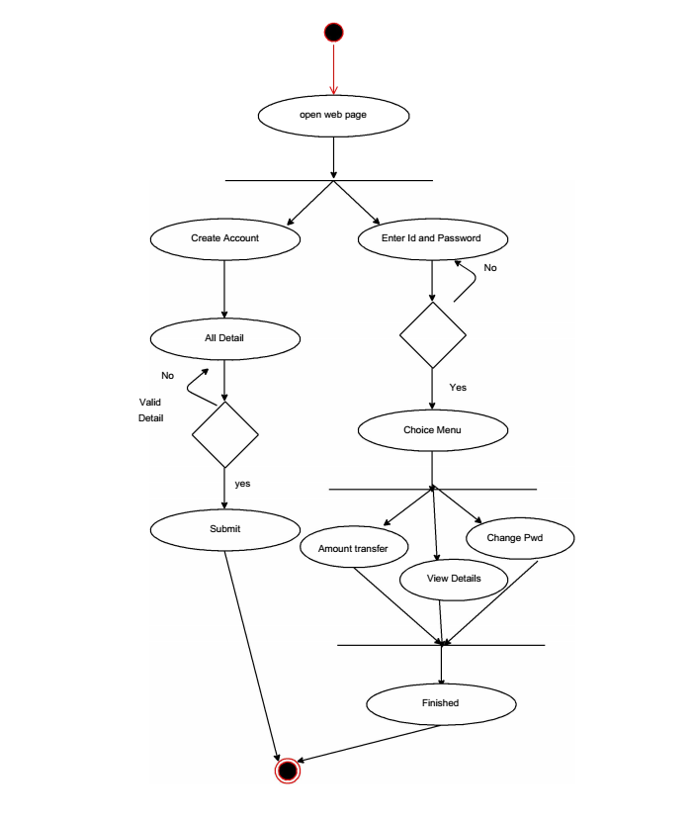

# USE CASE Diagram

Login

Create A/c

Update A/c

Delete A/c

Transfer

Withdrawal

Deposit

A/c Info

Tran. Report

Year Report

Log out

Customer

Employee

Admin

# Data Dictionary

A data dictionary is a collection of descriptions of the [data](http://searchdatamanagement.techtarget.com/definition/data) objects or items in a data model for the benefit of programmers and others who need to refer to them. A first step in analyzing a system of [object](http://searchsoa.techtarget.com/definition/object)s with which users interact is to identify each object and its relationship to other objects. This process is called data modeling and results in a picture of object relationships. After each data object or item is given a descriptive name, its relationship is described (or it becomes part of some structure that implicitly describes relationship), the type of data (such as text or image or binary value) is described, possible predefined values are listed, and a brief textual description is provided. This collection can be organized for reference into a book called a data dictionary.

|  |  |  |
| --- | --- | --- |
| Sr No. | Table Name | Description |
| 9.1 | Branch Info | This table contains information about bank branch such as branch no. And branch name. |
| 9.2 | Deposit Info | In this table it contains the information about amount and depositor who has deposited amount in account. |
| 9.3 | Login table | It is the very first step to access the bank account.it contains username and password. |
| 9.4 | Withdrawal Info | In this table it contains the information about amount and withdrawer who has deposited amount in account. |

9.1 Branch Info

|  |  |  |
| --- | --- | --- |
| Fieldname | Type | Constraints |
| Branch no | Varchar(7) | Primary key |
| Branch name | Varchar(20) | Not Null |

9.2 Deposit info

|  |  |  |
| --- | --- | --- |
| Fieldname | Type | Constraints |
| Account no | Int | References Account info(Account no) |
| Branch no | Varchar(20) | Null |
| Depositor name | Varchar(20) | Not Null |
| Account type | Varchar(20) | Not Null |
| Deposit amount | Varchar(20) | Not Null |
| Deposit Date | Date Time | Not Null |

9.3 Login table

|  |  |  |
| --- | --- | --- |
| Fieldname | Data type | Description |
| Username | Varchar(20) | Primary Key |
| User Password | Varchar(15) | Not Null |

9.4 Withdrawal Table

|  |  |  |
| --- | --- | --- |
| Field-name | Type | Constraints |
| Account number | Int | References A/c info(Account number) |
| Branch no | Varchar(7) | Null |
| Withdrawal name | Varchar(15) | Not Null |
| Account type | Varchar(15) | Not Null |
| Withdrawal | Varchar(15) | Not Null |

# Form Design (Screenshots)

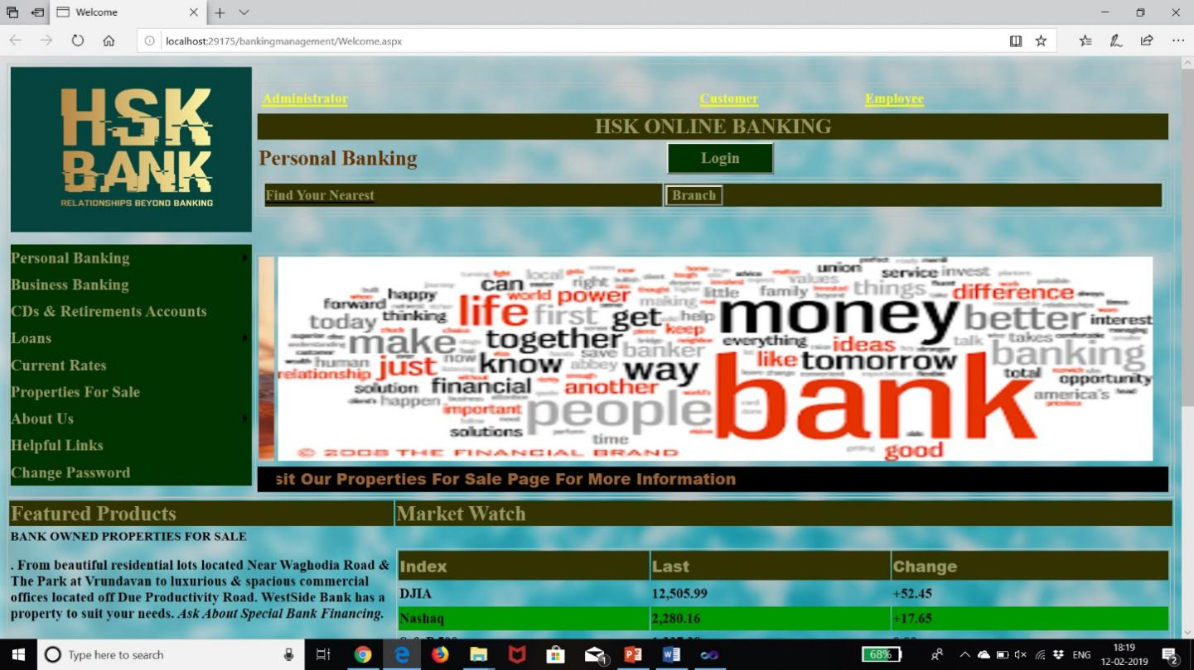

Fig 10.1 Main Page

This is the main page which is shown on when we open the web page and it is also known as homepage or Master page.

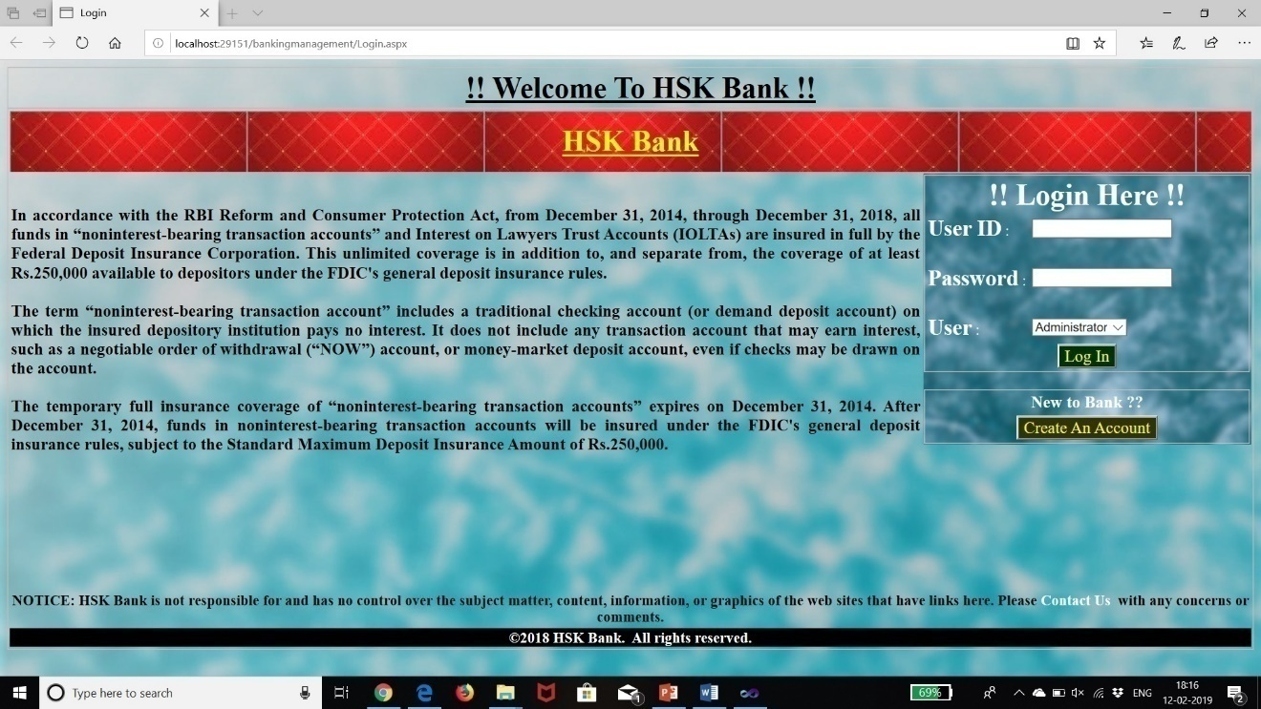

Fig 10.2 Login Page

After the homepage this page comes which is the login page which allows the user to access into the server.

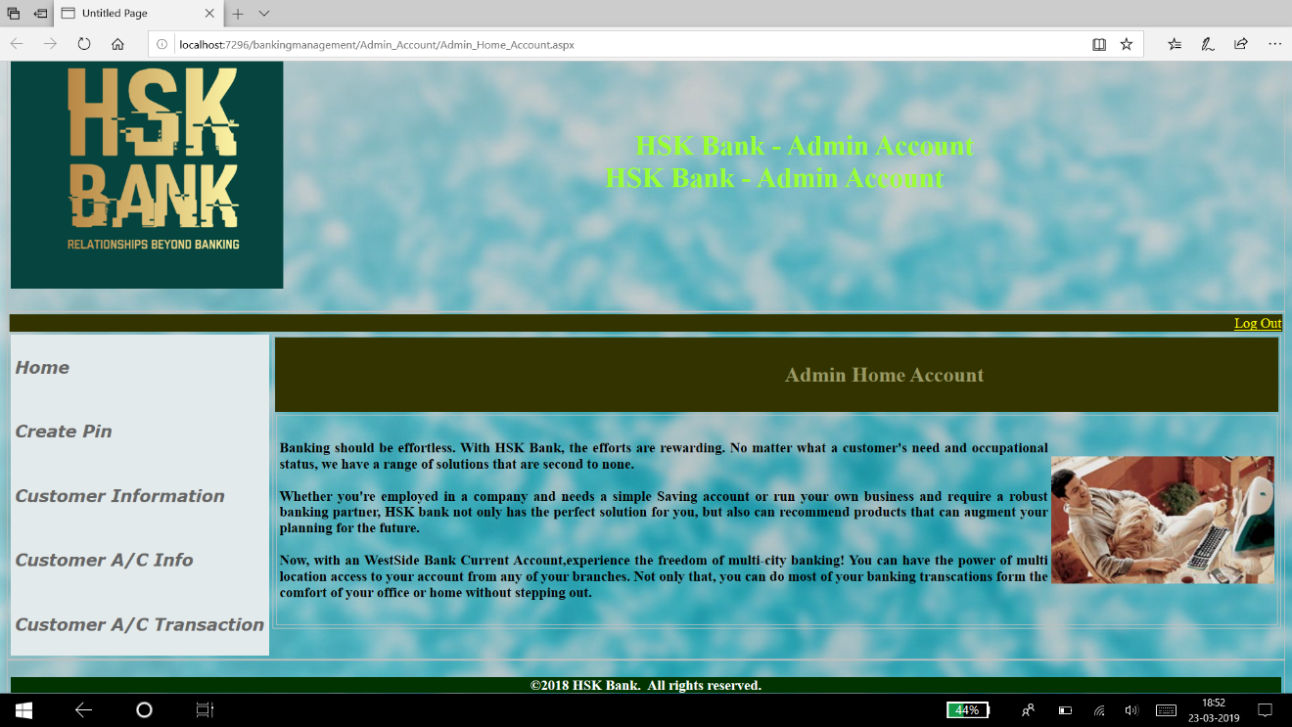

Fig 10.3 Admin Home Account

After login into the admin page we see the above page which we used to check the reports of all the things

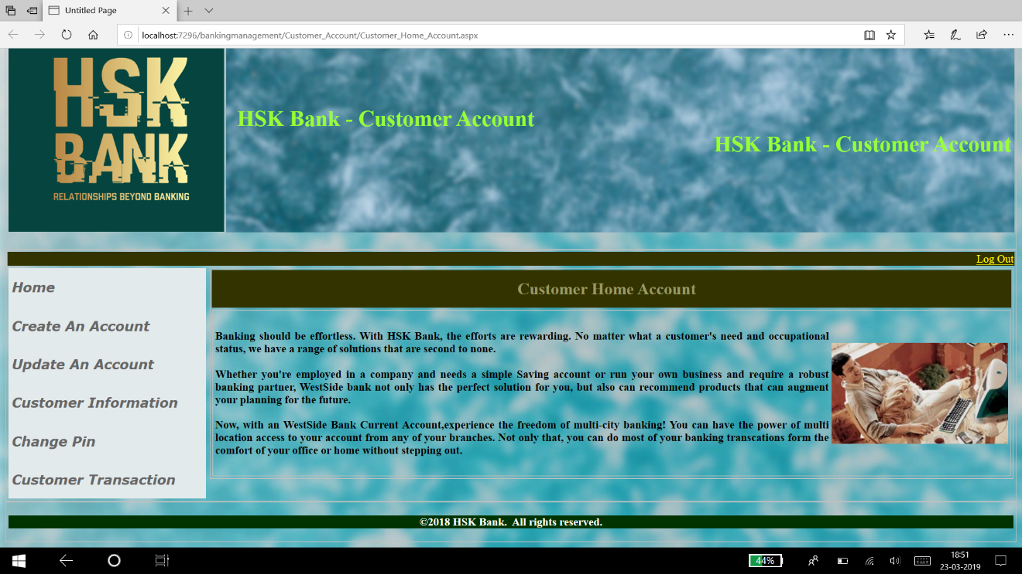

Fig 10.4 Customer Home Account

This page occurs when we login with customer account and it is the path which is used for taking the reports of the particular customer.

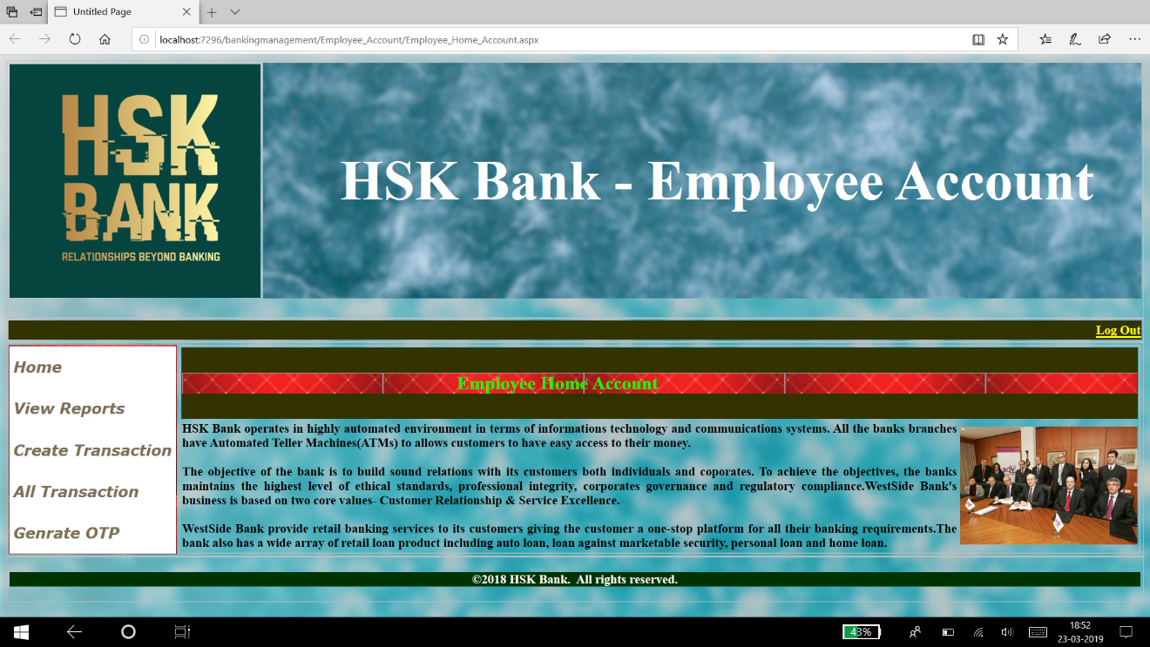

Fig 10.5 Employee Home Account

This is the actual page is view when we make want to transfer money from the bank person such as when we visit the bank the employee work is actual done in this phase.

# Future Enhancement

**Current status of project: -**This project is now wards complete but we can add more things like ATM, Online Transactions through Online Banking.

**Remaining areas of concern: -** This software project is complete and can be used to access records, can generate reports whenever necessary or needed.

**Technical and managerial lessons learnt : -** During the development of project we have learnt many lessons like the rules prevailing within an organization like: -

1)Proper defined structure.

2) Good chain of commands.

3) Work should be divided among each other.

**Future recommendations: -**As we all know that the change is permanent, so according to change this project can be modified or manipulated according to needs.

# 12 .BIBLIOGRAPHY

**W3School-** we have learn several command using this website which make us to execute our program as we know that without studying from latest technology we cannot make our project.

**YouTube-** The second most useful for developing our project is YouTube in which we watch video for implementing our program such as connecting database, firing query and many more.

**Books**

Learning ASP.Net and C# .Net. **-**Ramesh Baangia.

ASP.Net 4 - Stephan Walther.

**Web References**

**<https://www.w3schools.com/asp/webpages_intro.asp>**

**<https://www.tutorialspoint.com/asp.net/>**

**<http://www.pragimtech.com/free-aspnet-video-tutorial.aspx>**